Exciting Geospatial Task Updates

I am thrilled to share geospatial task on a recent project I have been working on with a certain company, a leader in connecting informal retailers with fast-moving consumer goods. My task focused on enhancing our dynamic routing strategy to optimize delivery efficiency. Dynamic routing involves creating the most efficient delivery routes by grouping orders to minimize costs and maximize vehicle utilization. In this project, I concentrated on one critical aspect: clustering shops around fulfillment centers to streamline our delivery process.

Why the task was a geospatial task

1. **Geospatial Data Handling:** Clustering shops around fulfillment centers involves managing and analyzing geographical data. This includes plotting locations on a map, determining distances between points, and optimizing routes based on spatial considerations.
2. **Distance Calculation:** The optimization of delivery routes relies on calculating distances between shops and fulfillment centers, which is a core aspect of geospatial analysis.
3. **Visualization:** Plotting the output on a map to visualize the clustered shops and optimized routes is a direct application of geospatial techniques. This helps in understanding the spatial distribution of shops and planning efficient routes.
4. **Routing Optimization:** The task of finding the shortest routes and optimizing vehicle capacity involves spatial algorithms that are integral to geospatial analysis.

In summary, the task encompasses key elements of geospatial analysis, including spatial clustering, distance calculation, and route optimization.

What I Did

* Algorithm Implementation: I developed an algorithm to cluster shops based on their proximity to fulfillment centers. This clustering optimizes delivery routes by reducing the total distance covered and improving vehicle utilization.
* Distance & Utilization Optimization: By carefully selecting combinations of orders that cover the shortest distance while ensuring maximum vehicle capacity utilization, we have significantly reduced fuel and vehicle costs.
* Visualization: I have plotted the clusters on a map to visually represent the optimized delivery routes. This helps in better planning and executing our delivery strategy.

Results & Insights

* Cost Reduction: The new routing strategy has led to a noticeable reduction in fuel costs and vehicle trips.
* Enhanced Efficiency: Improved vehicle utilization has maximized our delivery capacity, reducing the number of trips needed.
* Strategic Planning: Visualizing clusters on the map has provided clearer insights into our delivery network, aiding in better decision-making.

Screenshots of the Output

My code

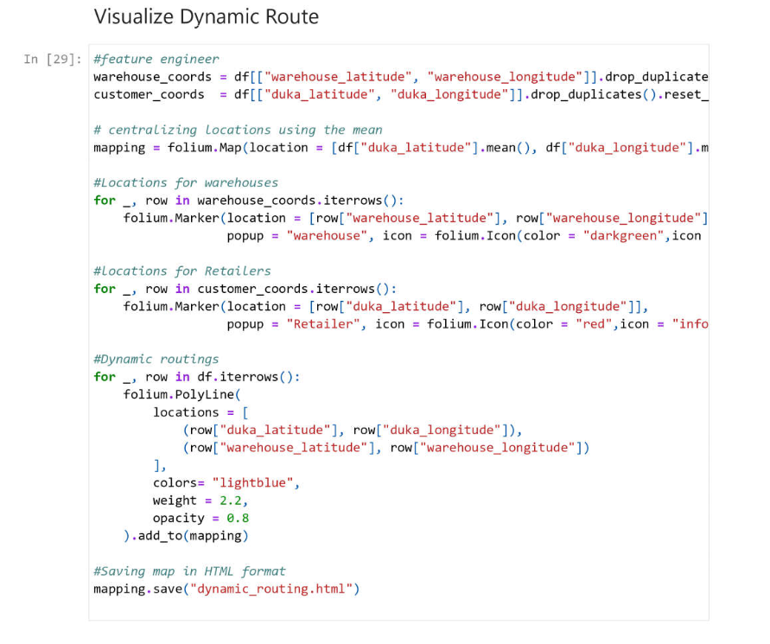

Map

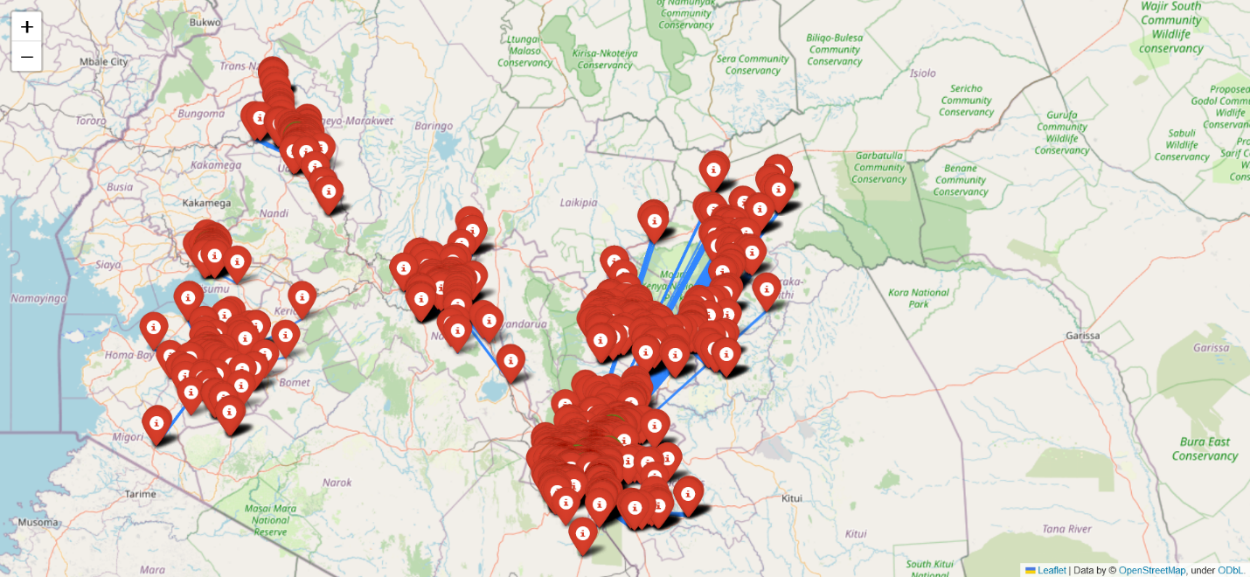

I am proud of the progress we have made in improving our delivery efficiency and look forward to seeing further advancements as we continue to optimize our routes.

#DynamicRouting #Optimization #Logistics #TechInnovation #SupplyChain #FMCG #Efficiency #DataDriven

Feel free to reach out if you are interested in learning more about our approach or discussing similar challenges!